

**USER GUIDE**

**For**

**CORPERATE ACCOUNT OPENING & MAINTENANCE SYSTEM (CAMS)**

**Version 1.0**

China CITIC Bank International

**Classification: Internal Use**

**Proprietary Notice**

This CAMS User Guide provides a general walkthrough of the CAMS system from initiation through save and submit. The logical arrangement of the information, which is based upon the Functional Requirements Specification for Corporation Account & Maintenance System (CAMS) Phase 1 and 1A v1.5.1. This user guide aims to give the functional personnel or user a brief concept about the creation process of Corporate Account Opening through CAMS system, with the screen prints to depict examples of text under each TABS, for easy reference. It may not be intended to cover every issue that may arise. For more details, please refer to the Functional Requirements Specification for CAMS.

Remarks:

**“#”** is marked with the indication message, easily recognized by the user, as reading through the user guide, even printed in black and white.

**“Mandatory Field”** means that the field must be filled to complete a certain process that uses the field.

Table of Contents

1 Introduction 4

2 Application Scope 4

3 USO Client Environment 6

4 CAMS Application Creation 8

5 The 8 TABS Creation Process 12

5.1 Company Information 12

5.2 Related Party 19

5.3 Accounts 25

5.4 Banking Services 27

5.5 FATCA and CRS 32

5.6 Document List 38

5.7 Bank Use Only 40

5.8 Workflow History 46

6 To Go Before Click “SUBMIT” 47

# Introduction

Corporate Account & Maintenance System (CAMS) is a web-based front end processing system which is designed to support the corporate account opening procedures.

This user guide aims to help the functional personnel /relationship managers/ users for the customers to open the corporate account at ease, and exhibits the user experience to operate the CAMS system.

While this user guide sets forth the minimum operation concept of different parts on the Corporate Clients Account Opening Application Process with data base build up, such as Company information, Related Party, Bank Account Type, Banking Services, CRS and FATCA, Document Check List, and Compliance check, for launching a CAMS forms to customers to sign.

# Application Scope

* **Customer type**

1. New to bank – other than Existing to bank
2. Existing to bank – a company that has a current or savings account with status not equal to closed.

* **Company Information**

1. Company Name and identification Document
2. Company Information
3. Anticipated Source and Origin of Funds Passing Through the Account
4. Anticipated Monthly Transactional Activity
5. Details of Contact Person(s)

* **Related Party**

1. Particular

* Capacity of Related Party
* Authorized Signatory

1. Mandate

* Resolution Attached (Limited Only)
* **Bank Account Type**

1. Current account
2. Multi-currencies statement saving account
3. Call deposit account
4. Time deposit account

* **Banking Services**

1. ATM
2. Phone Banking
3. Business internet banking (BIB)
4. Corporate online banking (FCDB)
5. Chinese Correspondence Address
6. Trade Services (a checkbox only)
7. Business Card(s) (a checkbox only)
8. Foreign Exchange (“FX”) (a checkbox only)
9. Fax Indemnity (a checkbox only)

* **FATCA & CRS**

1. FATCA Certification
2. Declaration of Tax Residency (other than U.S.)

* **Document List**

1. Account Opening Checklist
2. Completed Account Opening Forms
3. Limited Company – Documents
4. Sole Proprietorship/Partnership-Documents
5. Other Types of Incorporation /Other Documents

* **Bank Use Only & Compliance Check**

1. Apply for Fee Waiver
2. Debit Instruction for Account Opening Charges
3. Risk Score Calculation
4. Negative List Checking
5. AML Name Scanning

* **Workflow History**

1. Export Workflow History
2. Action Date and Action History
3. User’s Message

# USO Client Environment

**Getting Started** with **USO**

3.1 USO Client Screen

Search “USO Client” from the Start Menu in Windows. The USO Client screen is as below:

Step 1: Click: “**Login**”

Step 2: Pop up window with **User ID** & **Password** to be filled in

Step 3: Type **User ID** & **Password**

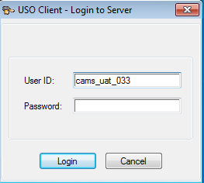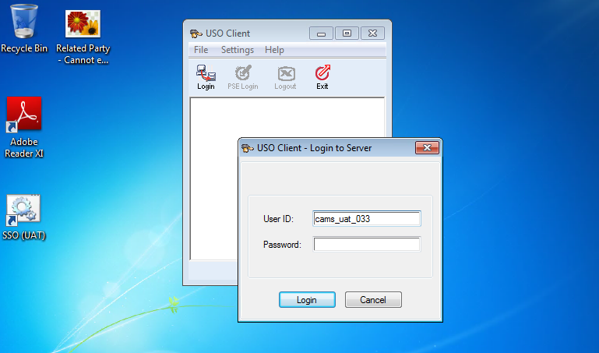

**#Click Login**

**#USO Client Screen**

**#Type User ID**

**#Type Password**

**Session Frame**

3.2 After login USO clients, then the **CAMS** displayed in the USO Client Box

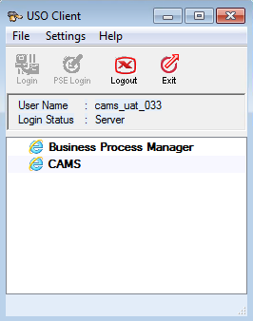

**#Click “CAMS”**

3.3

a)Click **CAMS**, to access the CAMS System

b) Pop up window will be shown with **AUTO FILL IN** login and password**.**

****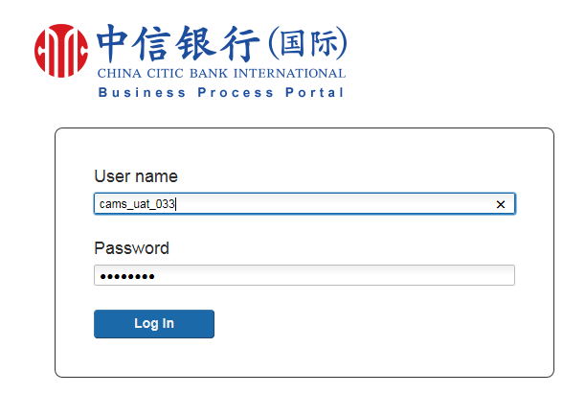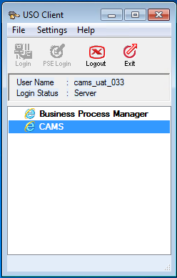

**#Click “CAMS”**

**#AUTO FILL IN**

c) After login CAMS interface through USO Clients

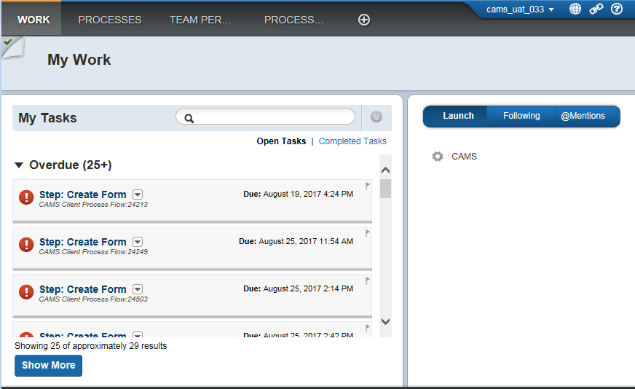

**#Task Enquiry**

**#Click “ CAMS '' to create corporate accounts**

**Session Frame**

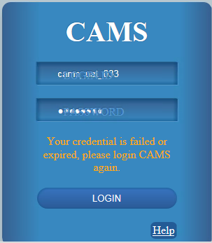

**#AUTO FILL IN**

**CAMS User ID & Password**

**No Need Press the Login Button**

**Session Frame**

# CAMS Application Creation

Corporate Account Opening Application (Creation)

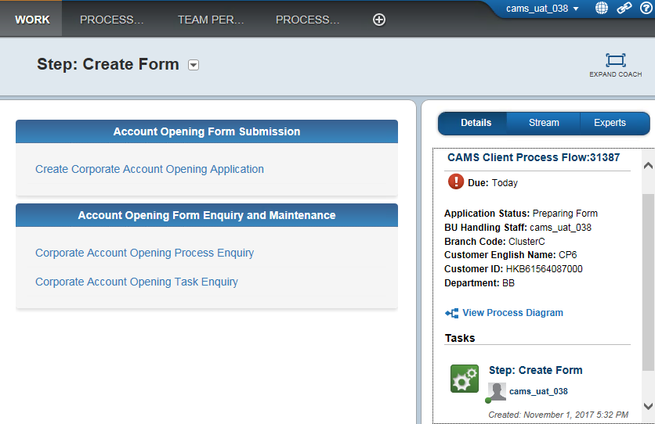

**#CLICK**

**#Your CAMS ID**

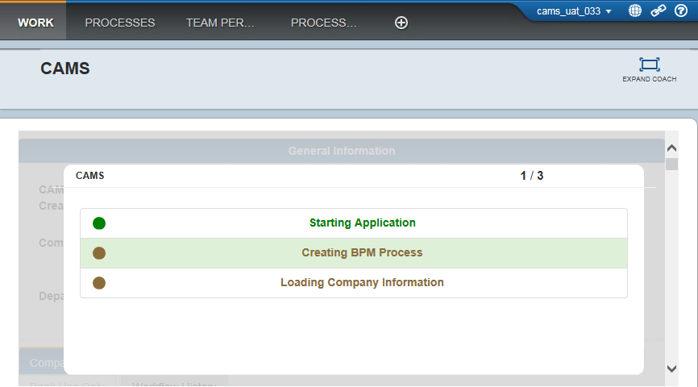

**#Loading Process**

4.1 Creation of Corporate Account Opening Application Process

* Type Company Name and identification Document.
* The mock-up screens in this section only display the fields for NTB customers in CAMS AOP form.
* The form header of a corporate account opening form is shown as following screen capture.

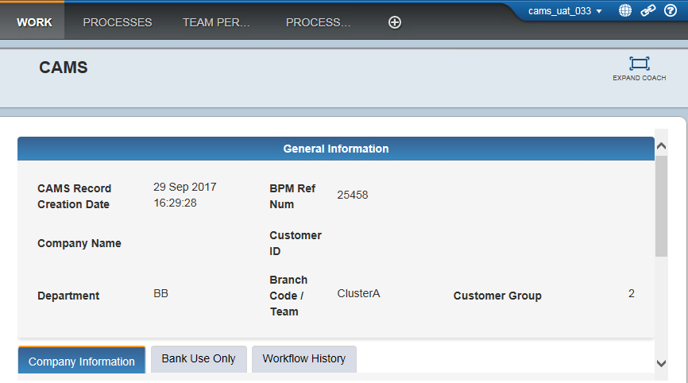

1. **#BPM Number generated by System**
2. **#Enquiry Search by BPM Number**

**#Generated by System & READ ONLY**

3 Fields to be filled in – **Country of Incorporation, Corporation ID Type and Corporation ID Number**

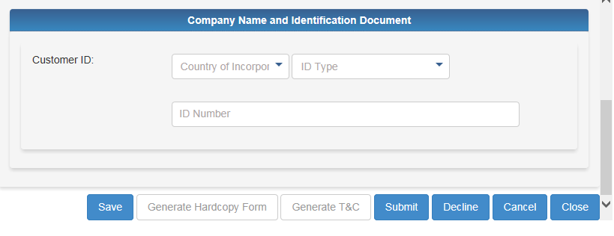

**#The length of BR number must be 11**

**e.g. 20895401000**

**#DropDown Menu**

**1.Business Registration**

**2.Certificate of Incorporation**

**3.Others**

**#FORMS BUTTON**

**#Mandatory Field**

**#Mandatory Field**

**#Mandatory Field**

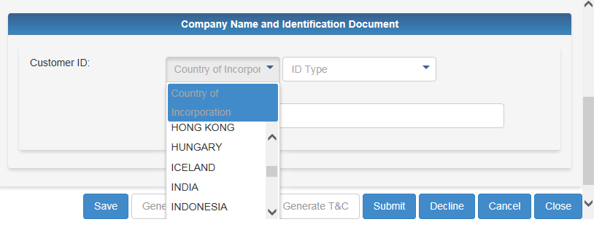

**#Country of Incorporation**

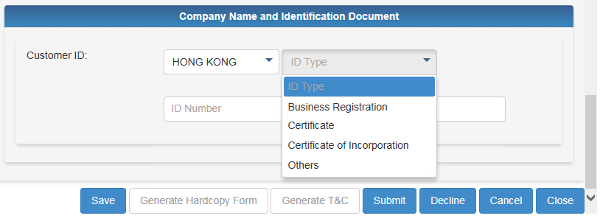

**#Identification Document Type**

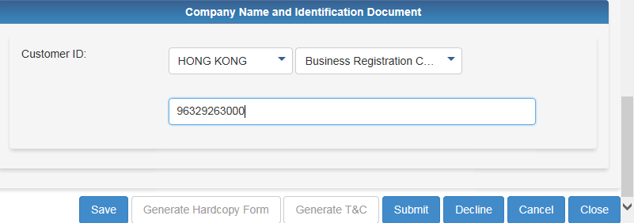

**#Click “Save” only to go further**

**No need to click “Submit”**

**# Identification Document Number**

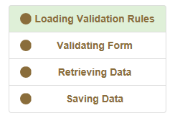

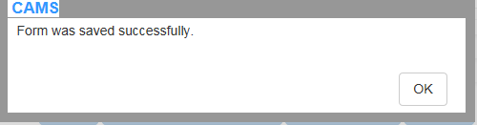

4.2 General User Interface Form Design

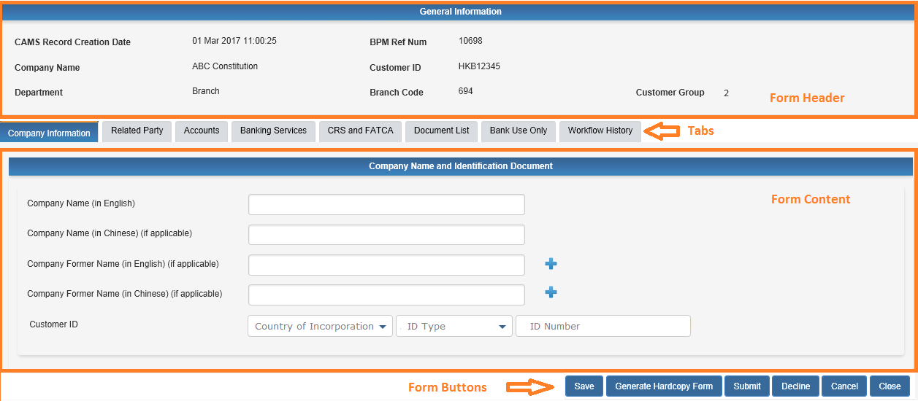

1. CAMS Form contains the following sections:
2. Form Header – shows information that is often referred to
3. Form Content – shows form content categorized by tab pages
4. Form Buttons – shows buttons user can use to take actions
5. The form content will be divided by tabs as illustrated in the above screenshot. It includes Company Information, Related Party, Accounts, Banking Services, FATCA & CRS, Document List, Bank Use Only and Workflow History.
6. Under each tab, system will only show the relevant sections and fields, details please refer to the following sections.
7. Field validation message will be displayed beside the field when the cursor leaves the field. Form validation such as validation that across multiple fields will be checked when user pressed an action button (e.g. submit, return). They will be displayed on a pop up box.

# The 8 TABS Creation Process

1. Company info 🡪 2. Related Party 🡪3. Bank Account 🡪 4. Banking Services🡪

5.CRS and FATCA🡪6. Document List🡪7. Bank Use Only🡪8.Workflow History

**8 TABS**

## Company Information

**3 Types of the Company** -**Sole Proprietorship** / **Partnership** / **Limited Company**

Company Information form will be shown after the company TAB is chosen. The Company

information form contains the following sections:

* Company Name and Identification Document - record the basic company information including **the name of company, Business registration or corporation registration ID**
* Company Information – include the incorporation date, country, contact and registered address. Additional information will also be needed such as nature of business, service and product, overseas operations and major competitors
* Anticipated Source and Origin of Funds Passing Through the Account
* Anticipated Monthly Transactional Activity
* Details of Contact Person(s) - if clients have provided any contact person, please also record in the application form

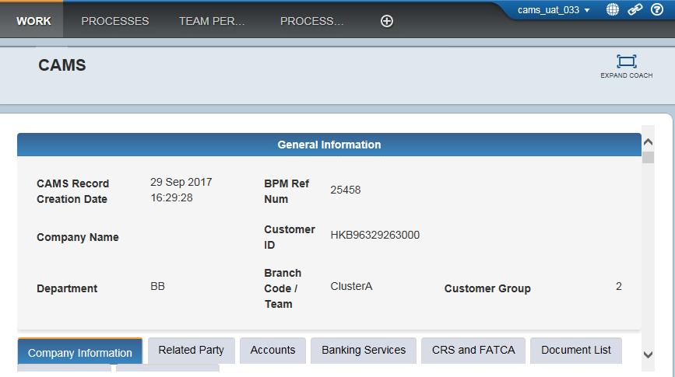

**COMPANY INFORMATION** (AT GLANCE) _1

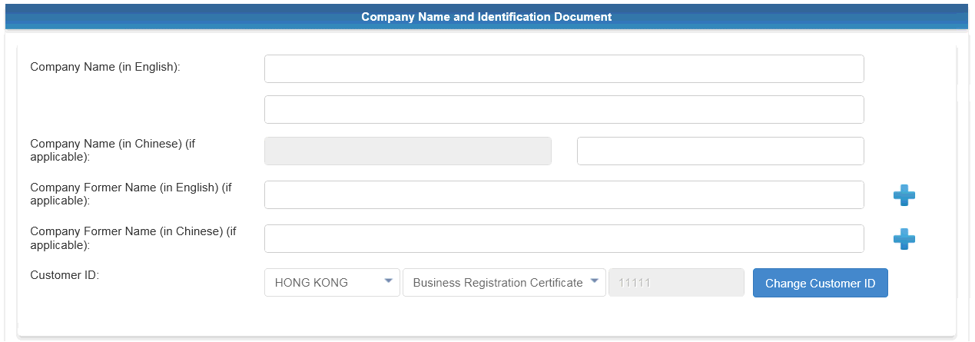

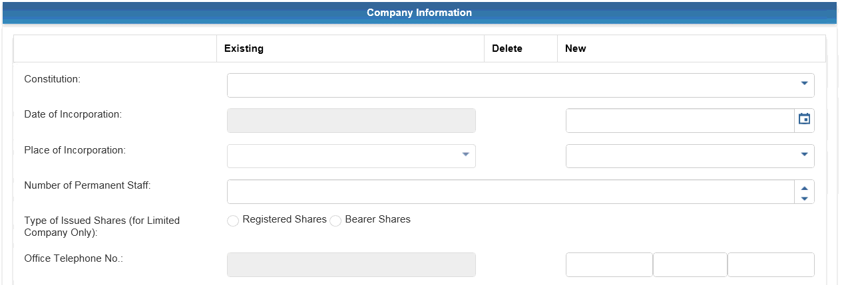

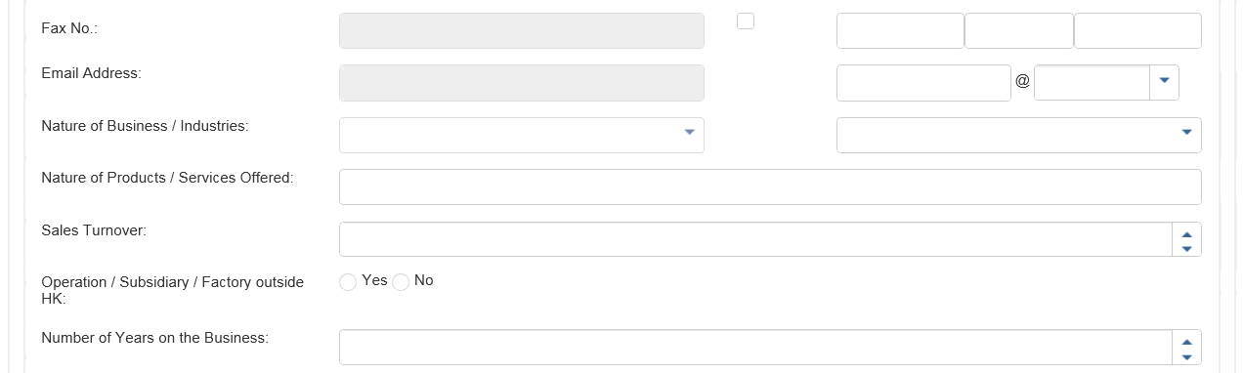

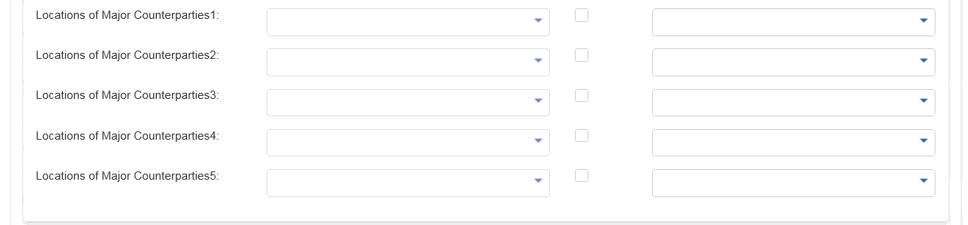

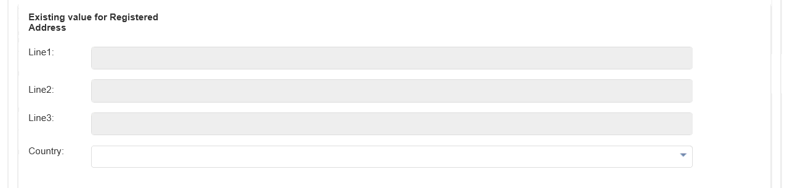

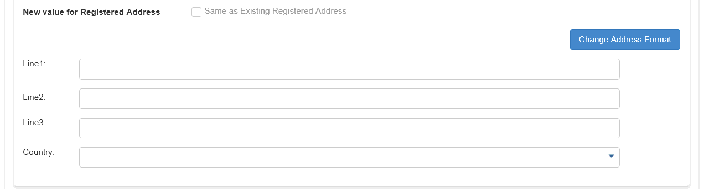

**COMPANY INFORMATION** (AT GLANCE) _2

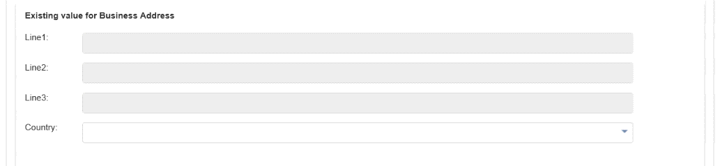

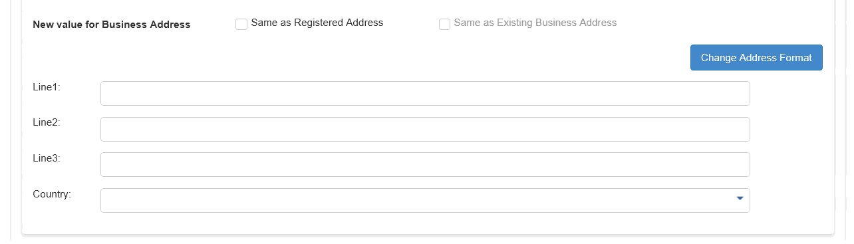

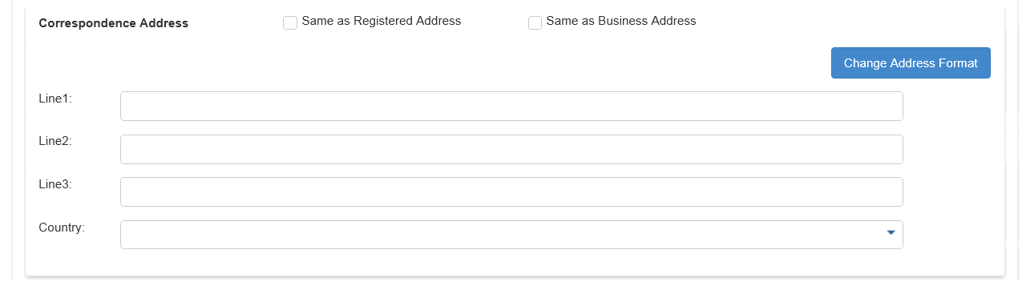

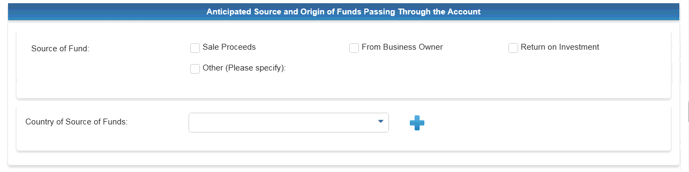

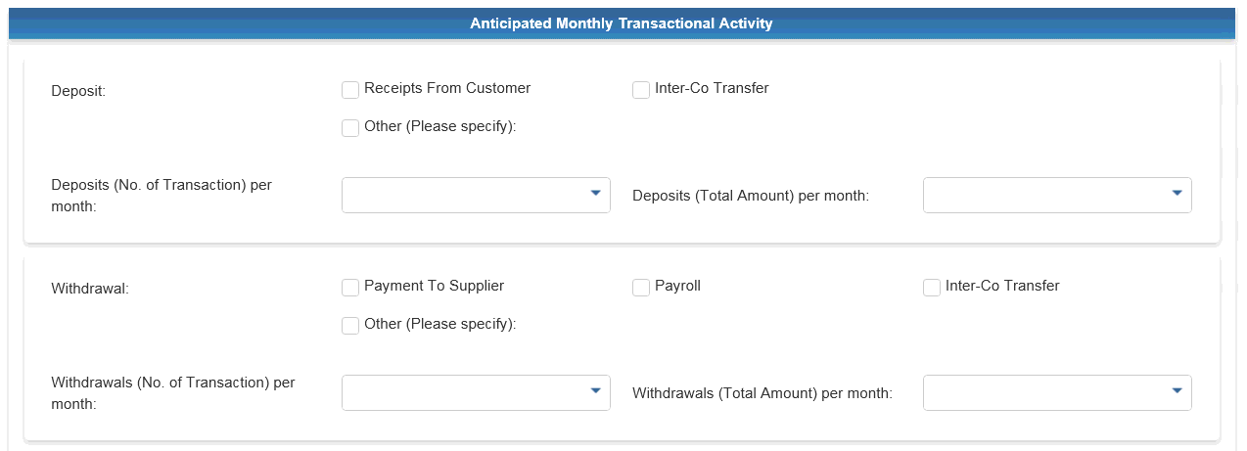

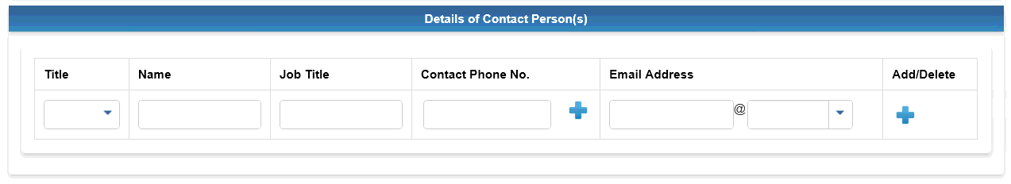

**COMPANY INFORMATION** (Zoom Page) _1

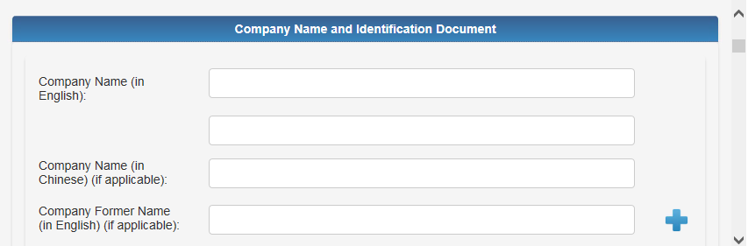

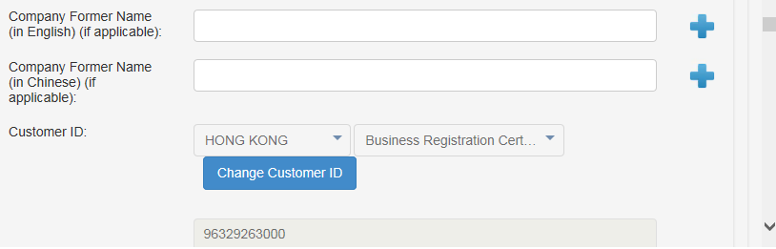

**#Auto Fill In**

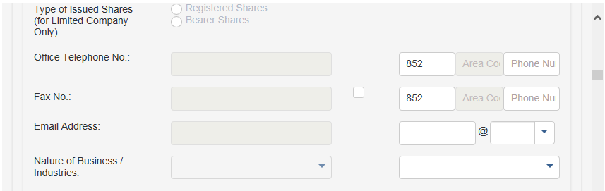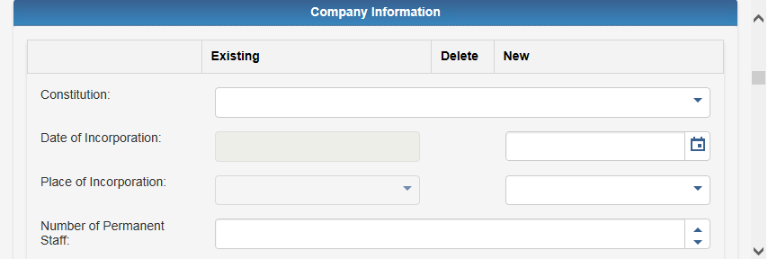

**#Mandatory Field**

**#Mandatory Field for Limited Company**

**#Mandatory Field**

**#Mandatory Field**

**#Mandatory Field**

**#Mandatory Field**

**#DropDown Menu**

**1. Sole Proprietorship**

**2. Partnership**

**3. Limited**

**#Date Format : DD MM YYYY, e.g. 31 Dec 2017**

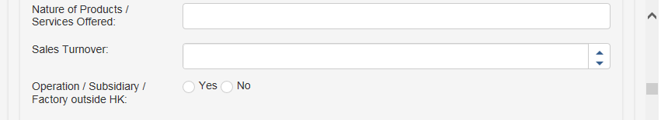**COMPANY INFORMATION** (Zoom Page) _2

**#Mandatory Field**

**#At Least 1 Option**

**#At Least 1 Option**

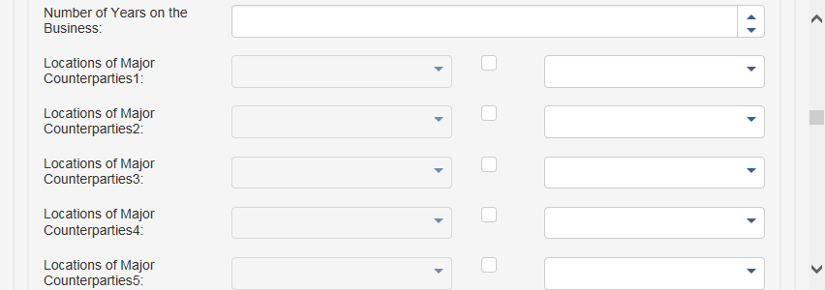

**#Mandatory Field**

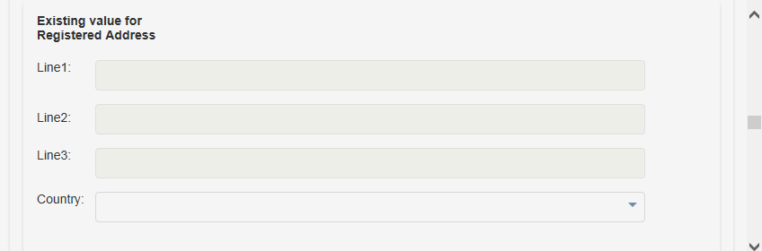

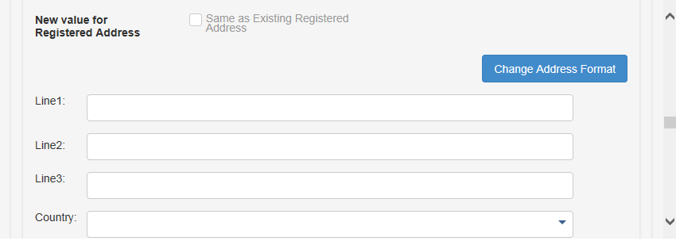

**#Mandatory Field**

**COMPANY INFORMATION** (Zoom Page) _3

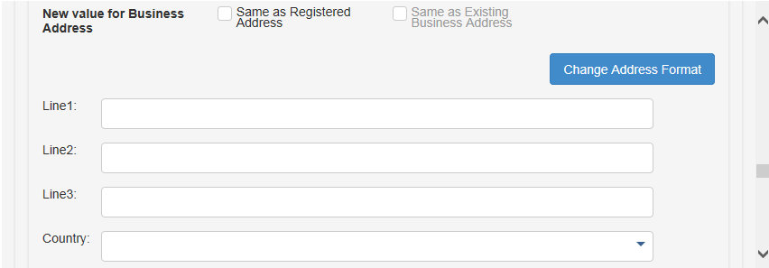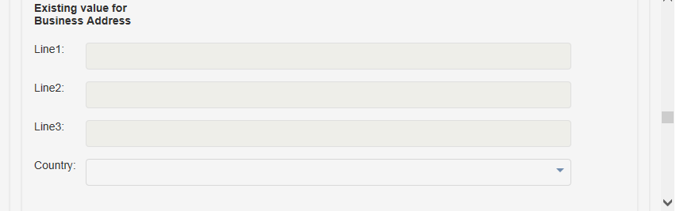

**#Mandatory Field**

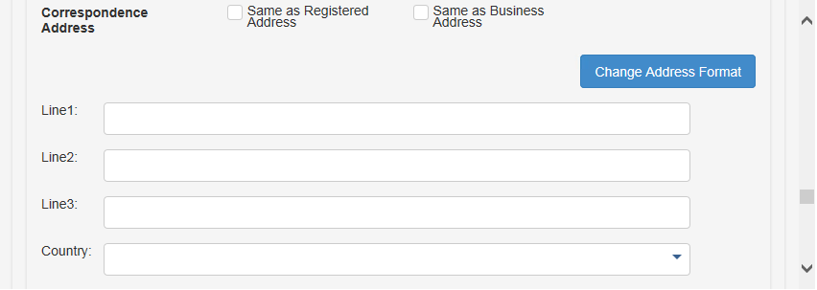

**#Mandatory Field**

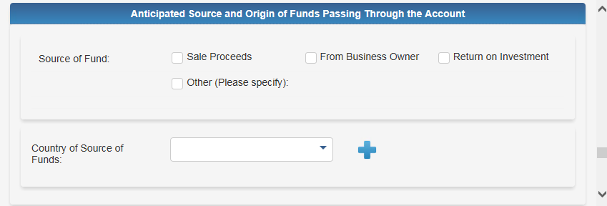

**#At Least 1 Option**

**#Mandatory Field**

**COMPANY INFORMATION** (Zoom Page) _4

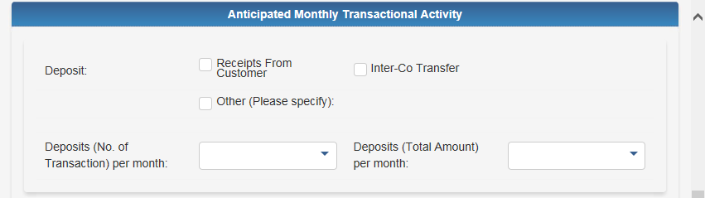

**#Mandatory Field**

**#Mandatory Field**

**#At Least 1 Option**

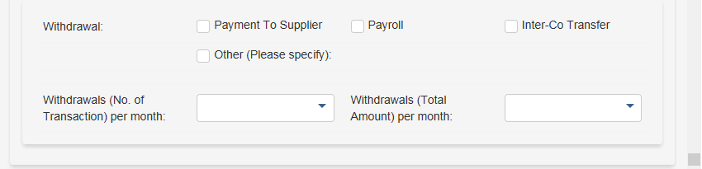

**#At Least 1 Option**

**#Mandatory Field**

**#Mandatory Field**

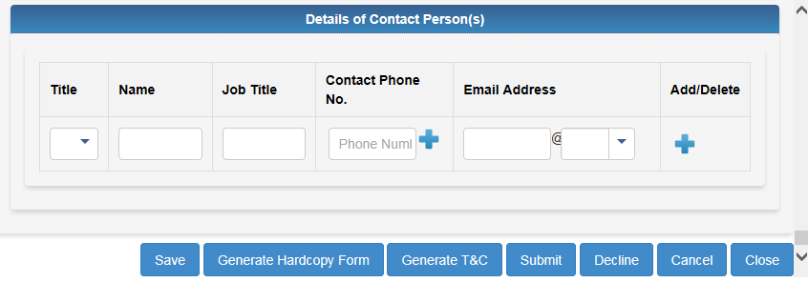

## Related Party

Related Party tab contains **Particulars** and **Mandate** sections.

**5.2.1 Particulars**

* + 1. At least to select one capacity type for one related party.
    2. At least one authorized signatory is required.
    3. At most 50 related party records can be added for a non-sole proprietorship company.
    4. User can edit more one related party at a time. To add a new related party, click the “add” button. While clicking on “delete” button will delete the corresponding related party on the form.

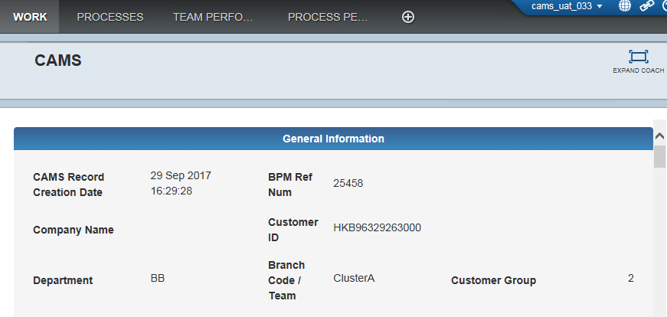

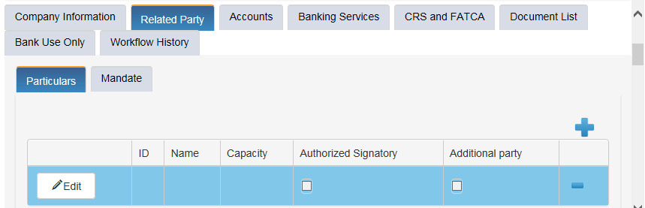**RELATED PARTY_PARTICULAR** (At Glance) _1

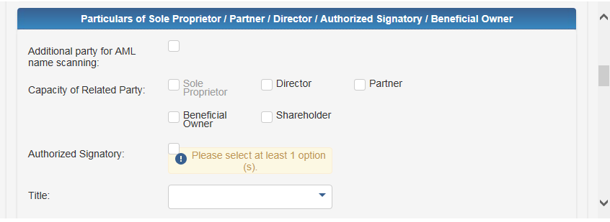

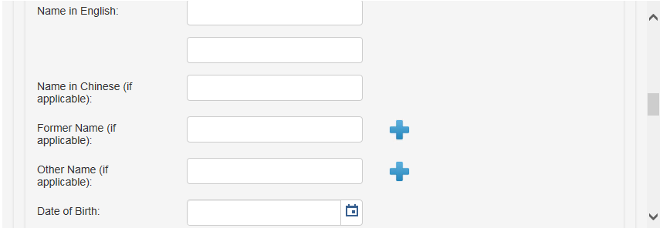

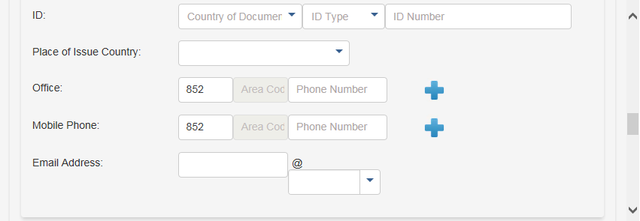

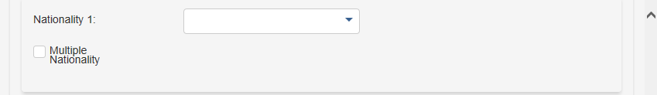

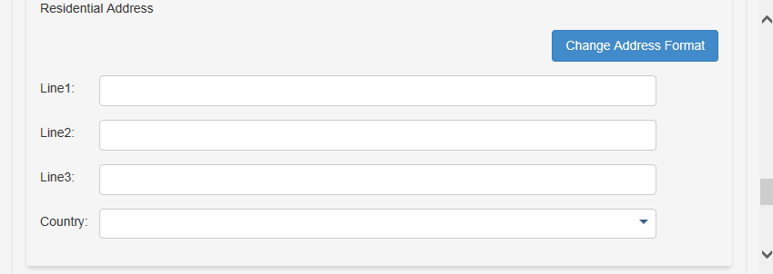

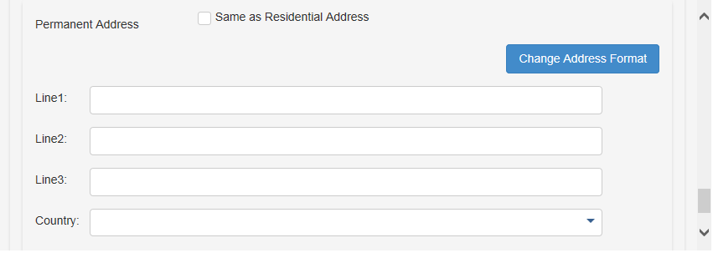

**RELATED PARTY_PARTICULAR** (Zoom Page) _1

**#PART 2**

**#PART 1**

**#2 Parts to Fill In**

**#Mandatory Field**

**# 2 Parts to fill in**

**# PART 2**

**# PART 1**



**#At Least 1 Option**

**# At Least 1 Option**





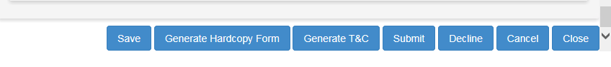**RELATED PARTY_PARTICULAR** (Zoom Page) _2

**5.2.2 Mandate**

The Mandate will be displayed according to the company type chosen in Company Information.

**RELATED PARTY_Mandate** (At Glance)

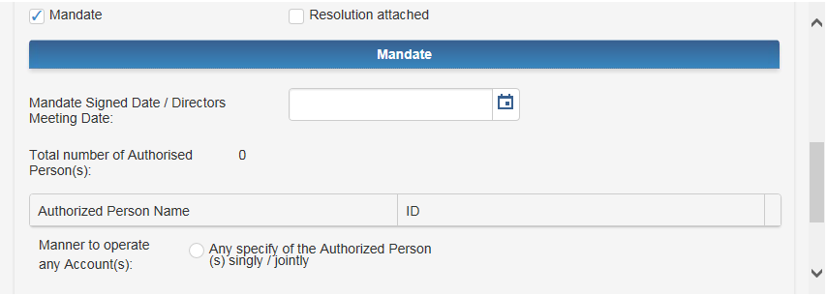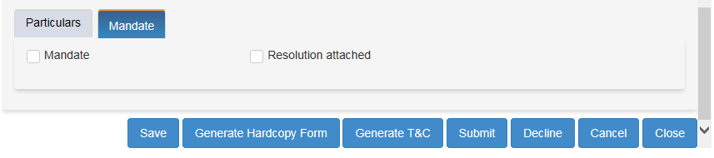

**#Date Format: DD MM YYYY, e.g. 31 Dec 2017**

**#Auto Fill In**

**Authorized Person**

**RELATED PARTY_Mandate** (Zoom Page)

1. In the Mandate sub-tab, Resolution Attached will be displayed if constitution is Limited Company or Others.



**#At Least 1 Option**

**#Mandatory Field**

1. By checking Mandate, the corresponding form of Mandate based on the constitution type will be shown.



**#Mandatory Field**

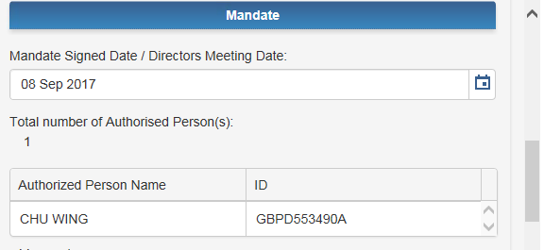

**#Mandatory Field**

**#Mandatory Field**

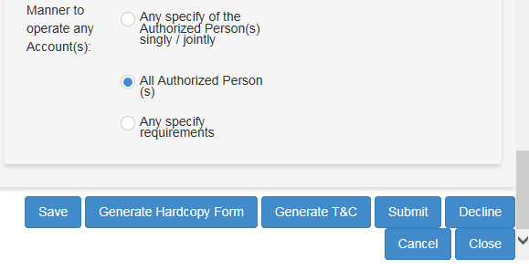

**#At Least 1 Option**

**#Mandatory Field**

**#At Least 1 Option**

## Accounts

1. User can fill in the purpose of opening account in Accounts tab. More than one option can be selected. If “Others” is selected, a text box will appear for input.
2. User can select account type in Account Details section.

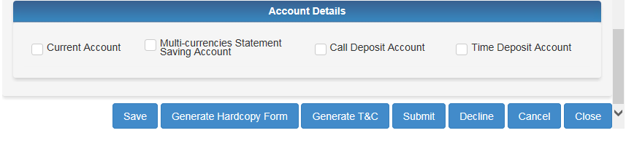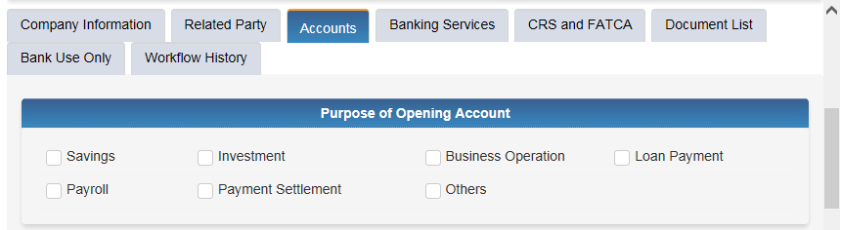

**#At Least 1 Option**

**#At Least 1 Option**

**5.3.1 Current Account**

1. Current Account section must be filled if it has been checked in Account Details.
2. 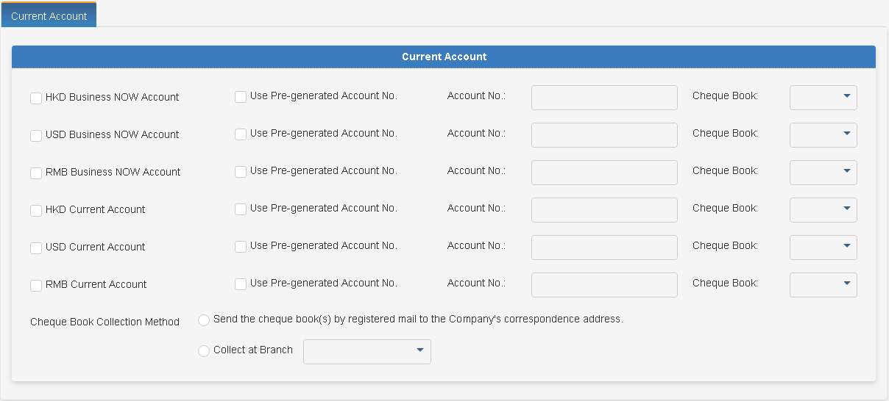Mandatory if use Pre-generated Account No. for any current account type is checked.

**5.3.2 Multi-Currencies Statement Saving Account (MCSSA)**

1. Multi-currencies Statement Saving Account (MCSSA) tab appear if it is checked in Account Details.
2. At least one currency is Mandatory if MCSSA is checked in Account Details.
3. 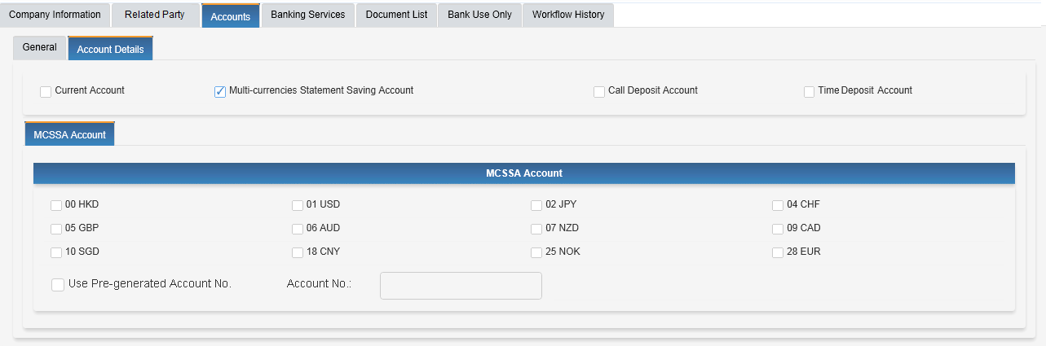A MCSSA can associate to multiple currencies.

### 

**5.3.3 Call Deposit Account**

1. Call Deposit Account tab appear if it is checked in Account Details.
2. At least one currency is Mandatory if Call Deposit Account is checked in Account Details.

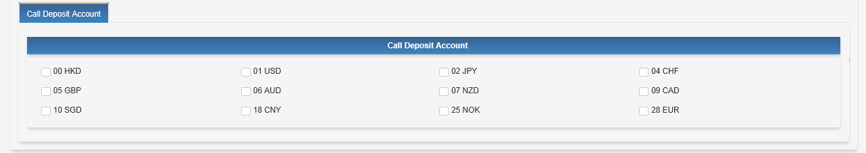

**5.3.4 Time Deposit Account**

1. Time Deposit Account tab appear if it is checked.
2. At least one currency is Mandatory if Time Deposit Account is checked in Account Details.

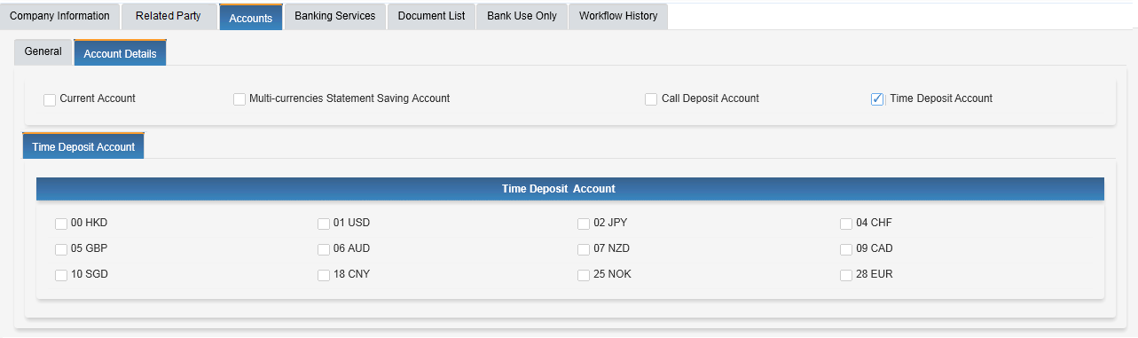

## Banking Services

1. More than one banking services can be selected and the corresponding tab will appear when it is checked, except for Trade Services, Business Card(s), Foreign Exchange Services and Fax Indemnity which have no additional information to input.

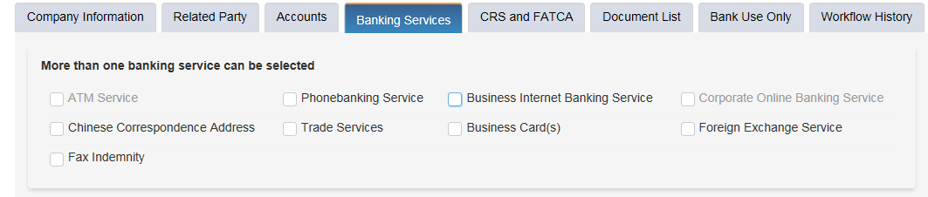

**5.4.1 ATM Service**

1. For only sole proprietor company, user can select ATM services for authorized person.
2. User can only choose HKD-Account in Master Account for ATM card.
3. Other CNY/HKD Account will be shown in “Secondary and Other Account”

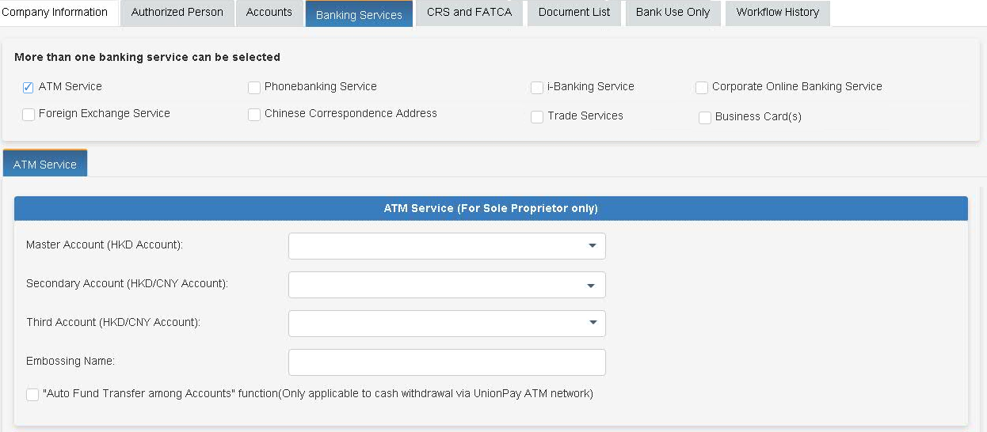

**#Mandatory Field**

**#Mandatory Field**

**#Master A/C – HKD**

**#Secondary A/C – HKD/CNY**

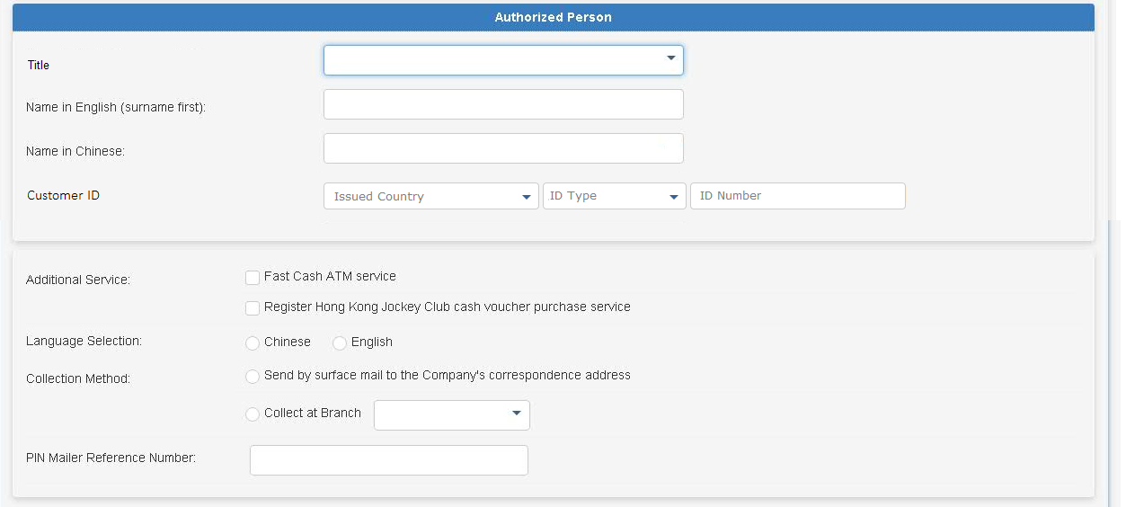

**#Mandatory Field**

**#Mandatory Field**

**#Mandatory Field**

**5.4.2 Phonebanking Service**

1. User can specify the account(s) to apply for phonebanking service.
2. User can only choose HKD account in Master account of Phonebanking service.
3. Other account options (any currencies) will be shown in “Secondary” and “Other” account.
4. User can input CNCBI account numbers to specify 3rd party accounts for receiving funds.
5. In Account maintained with other banks, user can select a bank code from the bank code list. The corresponding bank name will be shown.

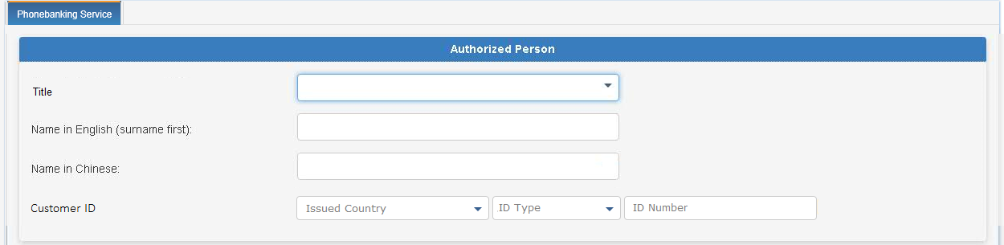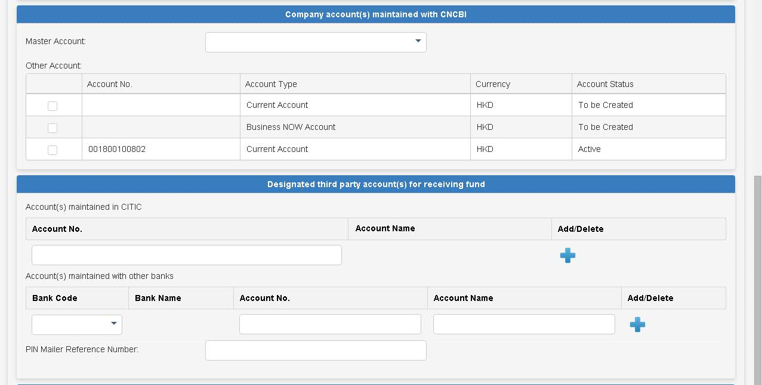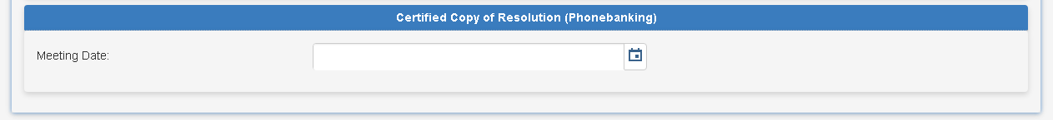

**#Mandatory Field**

**#Mandatory Field**

For customer other than Sole-proprietorship & Partnership

**#Date Format: DD MM YYYY, e.g. 31 Dec 2017**

**#Mandatory Field**

**#Mandatory Field**

**#Mandatory Field**

**5.4.3 Business Internet Banking Services (“BIB”)**

1. User can specify one authorized person to operate Business Internet Banking services.
2. The ID and email address of the authorized person will be shown.
3. User can input CNCBI account numbers and accounts maintained with other local banks to specify 3rd party accounts for receiving funds.
4. User can register Beneficiary’s Bank Account Information for Online Remittance.
5. User will need to complete “Certified Extract of Resolutions”.
6. BIB services and Corporate Online Banking services cannot be applied at the same time.

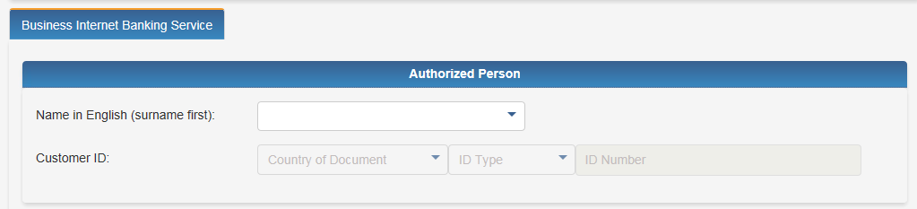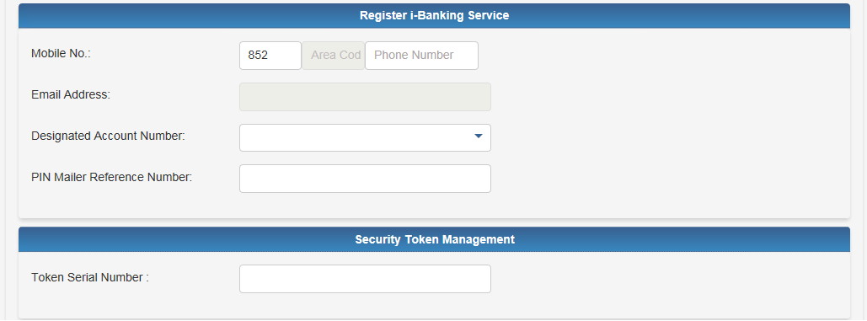

Authorised User of BIB must be Authorised Signer

Auto Fill in

BIB PIN Mailer / Security Token can only be upfront passed to the customer with the following criteria.

* Risk score is lower than 3
* NO hit in AML Name Scanning & Negative List Checking

**#Mandatory Field**

**#Mandatory Field**

**#Mandatory Field**

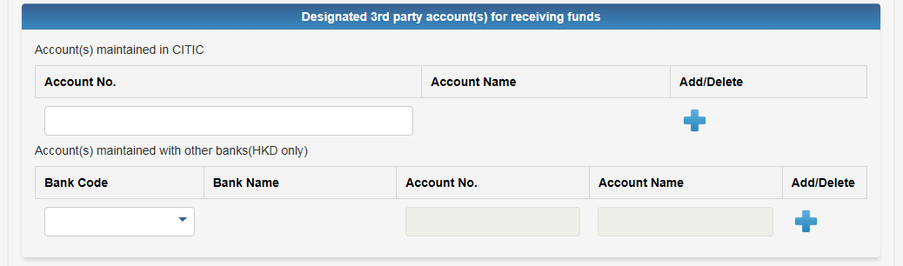

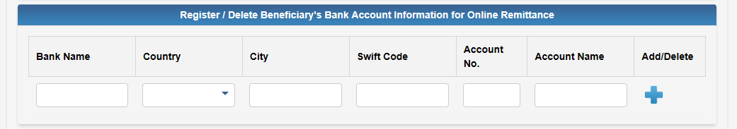

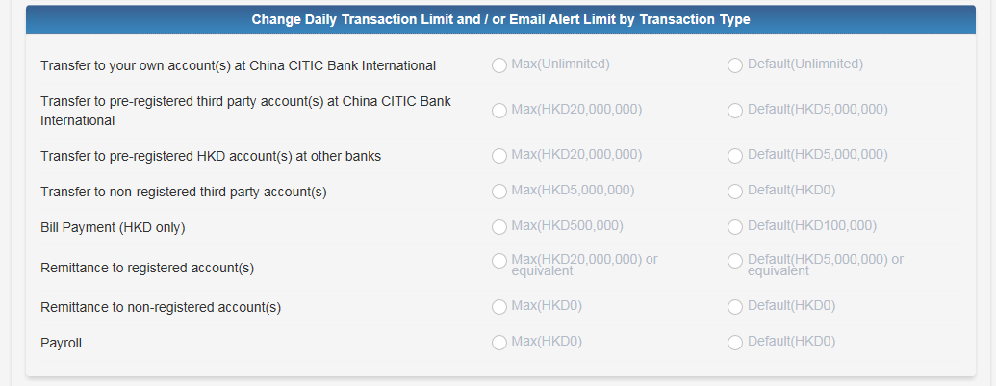

For customer other than Sole-proprietorship & Partnership

Display only

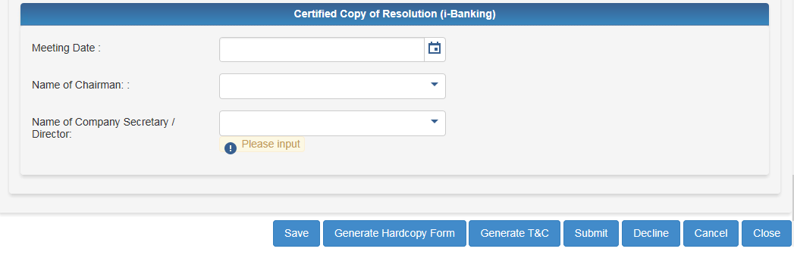

**#Mandatory Field**

**#Mandatory Field**

**#Mandatory Field**

**#Date Format: DD MM YYYY, e.g. 31 Dec 2017**

**5.4.4 Corporate Online Banking Services (“COB”) (will be launched in Q2 2018)**

1. User can input daily limit by transaction type in Change Daily Transaction Limit section.
2. In Account(s) to be accessed and operated through Corporate Online Banking Services section, current and savings accounts to be created in the account opening form and retrieved from RM trailer (for ETB) will be auto-filled for user to choose from.
3. Section of Certificate Extracts of Board Resolutions for Corporate Online Banking Services will be displayed for Sole-proprietorship, Partnership and Limited Company according to constitution type in Company Information tab. Wording of description in Board Resolutions section will be revised based on latest hardcopy form in UAT phase.
4. A customer can apply only either Business Internet Banking services or Corporate Online Banking services, CAMS will check whether an ETB customer has BIB or FCDB account from RM trailer.
5. If constitution is a value other than Sole-proprietorship, Partnership or Limited Company, no related information will be displayed in FCDB sub-tab.
6. At least one administrator is mandatory, maximum is 4 in creation of administrator section.
7. In Security Token Management section, token serial number for administrator will be displayed in accordance with the number of administrator, so that user can input the serial token number for administrator. And token serial number will be shown on the number by index.

**5.4.5 Chinese Correspondence Address**

**#Mandatory Field**

1. User can tick the Chinese Correspondence Address checkbox to input Chinese address and specify account(s) to be associated with this address.
2. Chinese Correspondence Address will be created for new accounts applied in CAMS AOP form only.

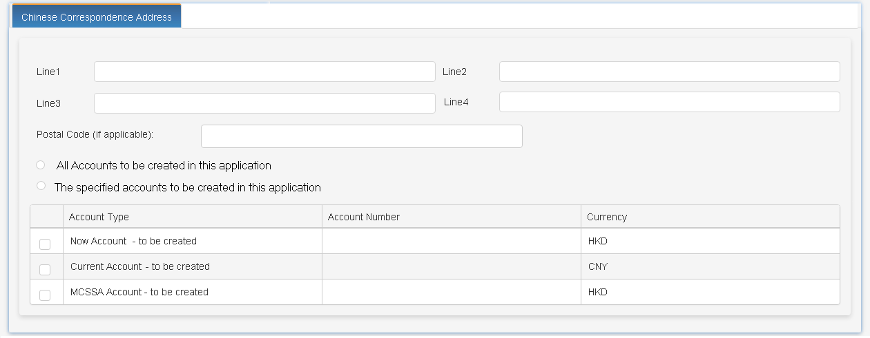

**#At Least 1 Option**

**#Mandatory Field**

## FATCA and CRS

**5.5.1 FATCA and CRS Self Certification (for Sole Proprietorship)**

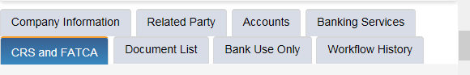

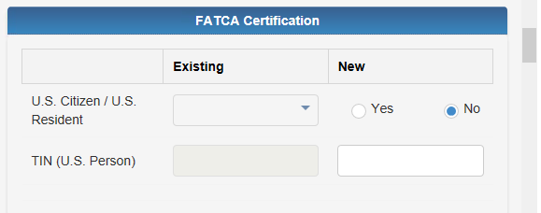

**#At Least 1 Option**

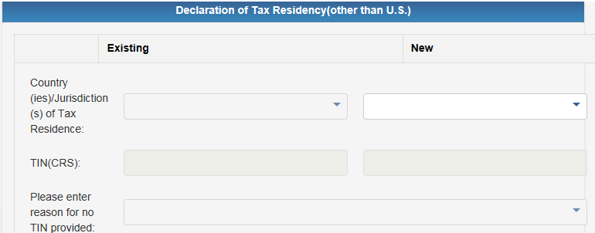

**#Mandatory Field**

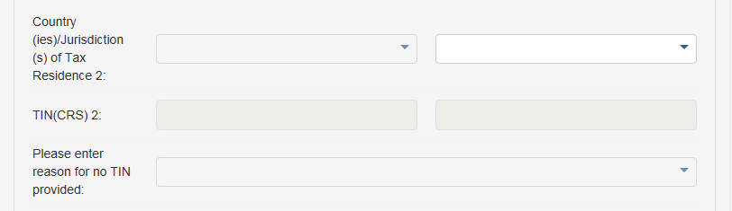

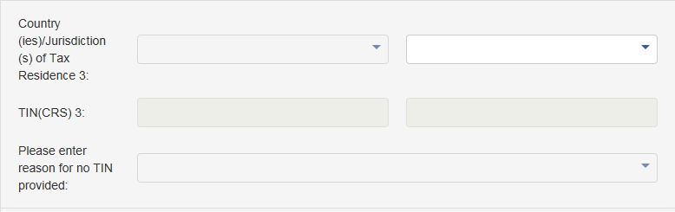

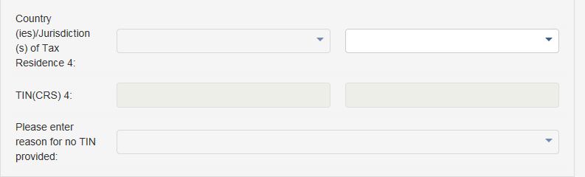

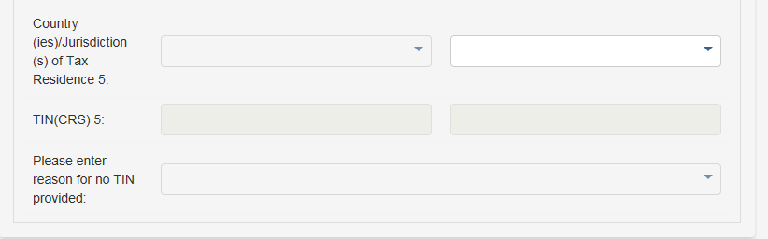

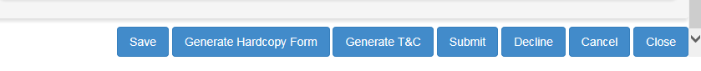

**5.5.2 FATCA Self Certification (for Entity)**

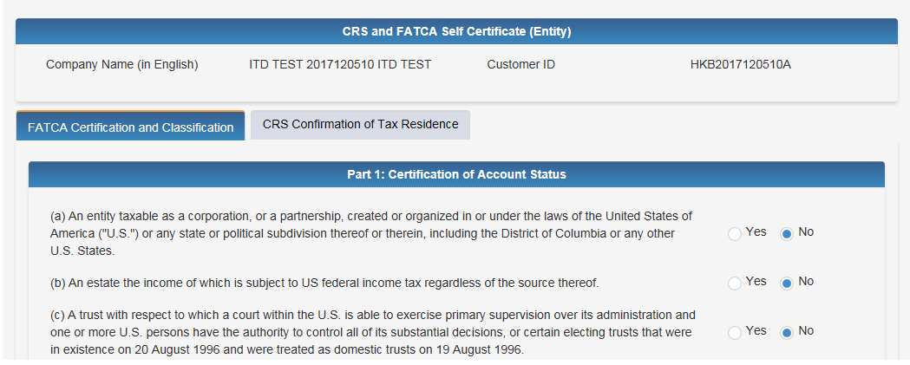

**#Mandatory Field**

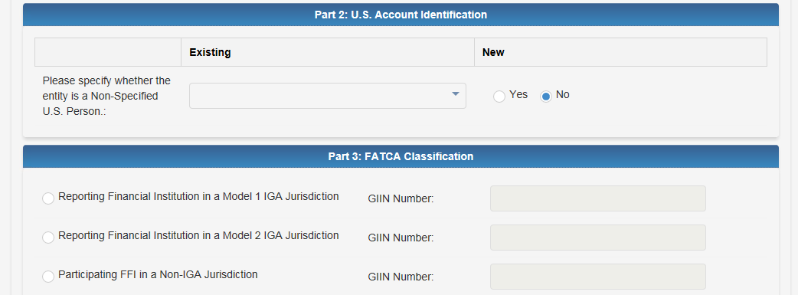

**#At Least 1 Option**

**#Mandatory Field**

**#Mandatory Field**

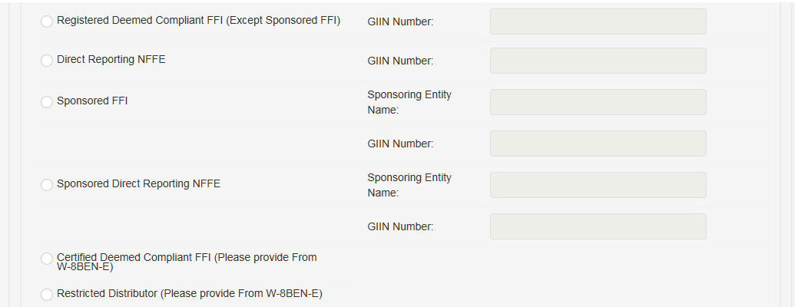

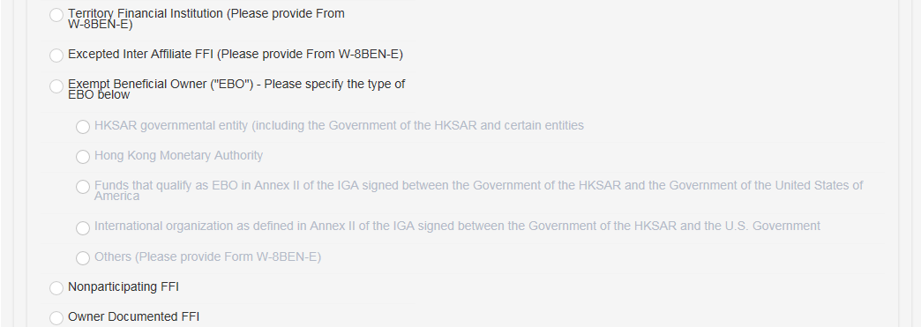

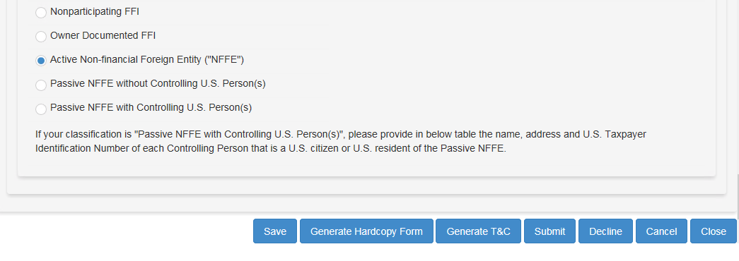

**5.5.3 CRS Self Certification (for Entity)**

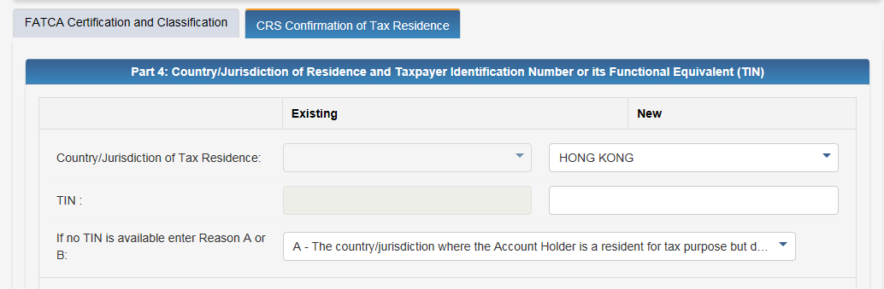

**#Mandatory Field**

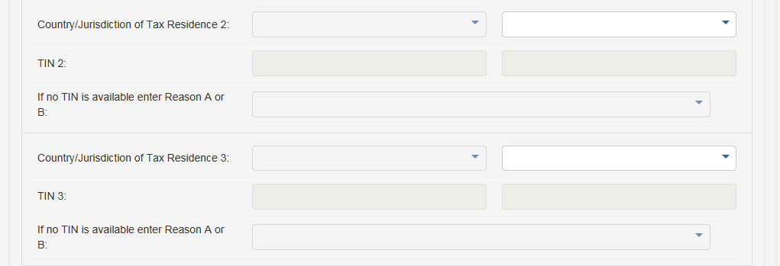

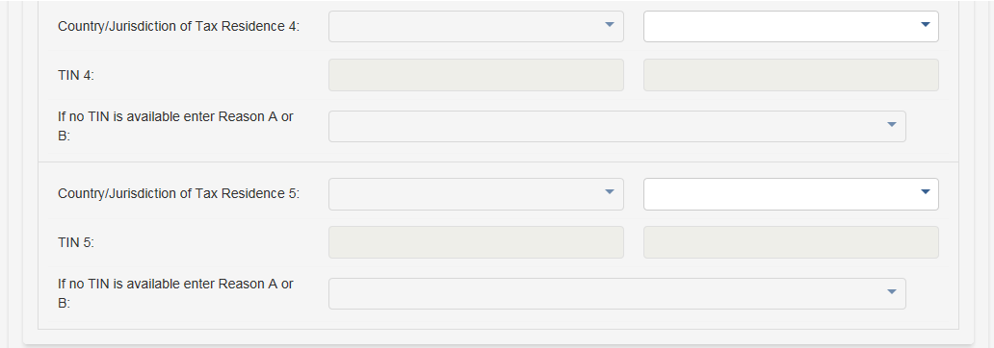

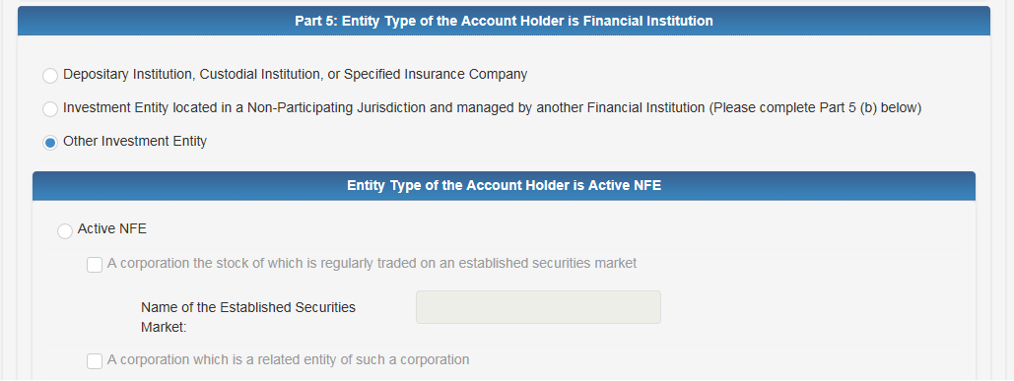

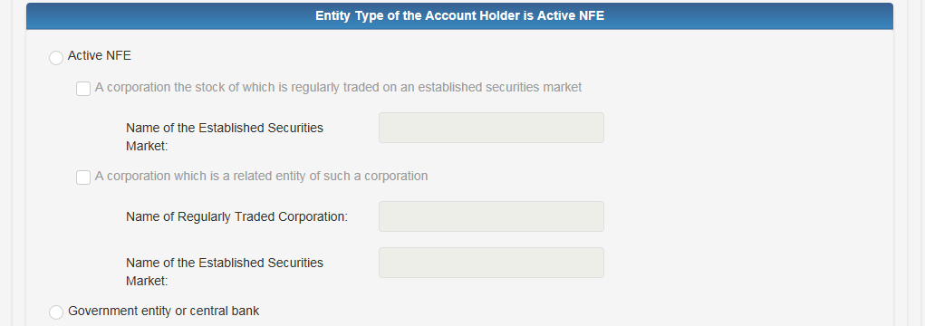

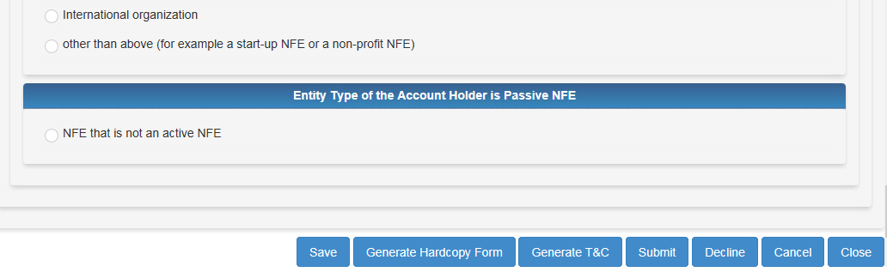

## **Document List**

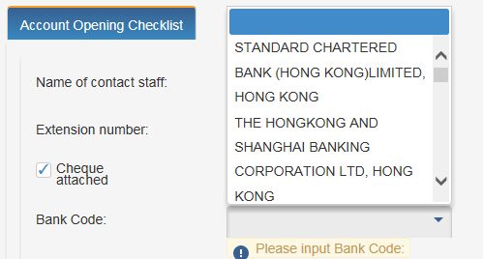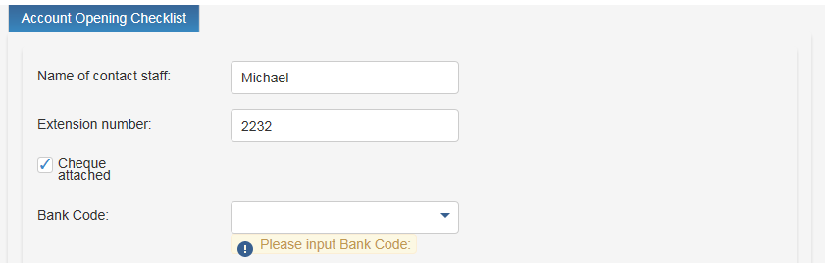

# Mandatory if cheque attached is checked

**#Mandatory Field**

**#Mandatory Field**

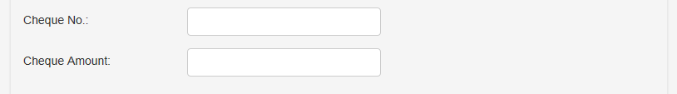

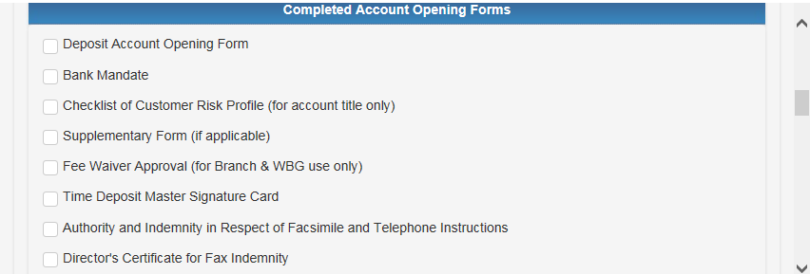

**#Mandatory Field**

**#Mandatory Field**

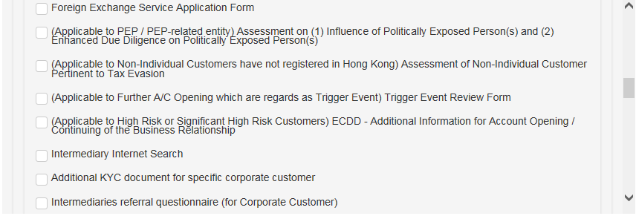

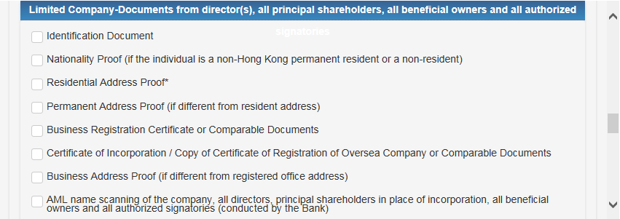

**#Mandatory Field**

**#Mandatory Field**

**#Mandatory Field**

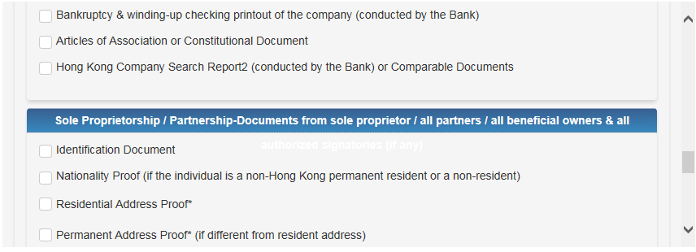

**#Mandatory Field**

**#Mandatory Field**

**#Mandatory Field**

**#Mandatory Field**

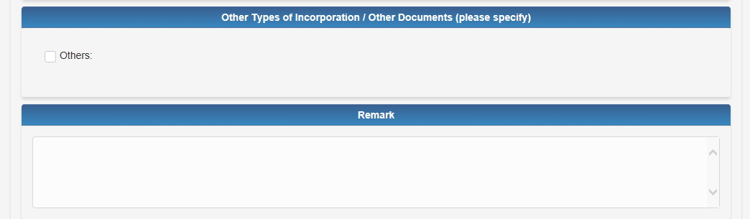



## Bank Use Only

1. This tab for user to input information for bank use only. It contains Bank Use Only and Compliance Check Result as two sub-tabs.
2. In sub-tab of Bank Use Only, account number of exiting active CASA account (ETB customer) and accounts to be created in this CAMS AOP form will be displayed in Debit Instruction for Account Opening Charges for user to choose.

**5.7.1 Bank Use Only**

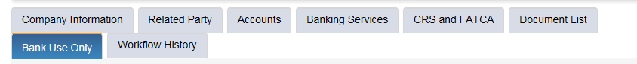



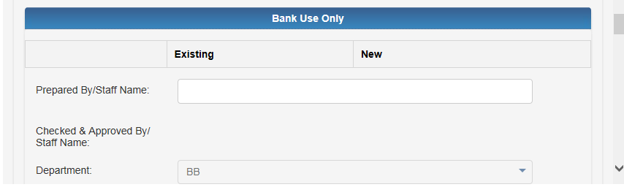

**#Mandatory Field**

**#Mandatory Field**

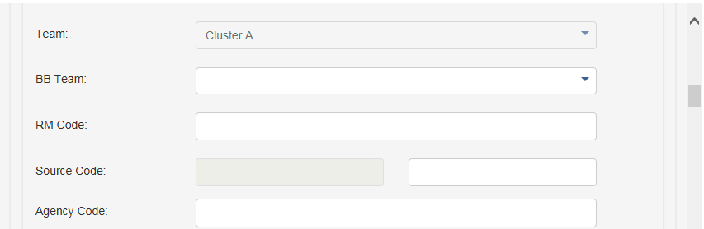

#Mandatory if department is

BB or WBG

**#Mandatory Field**

**#Mandatory Field**

**#Mandatory Field**

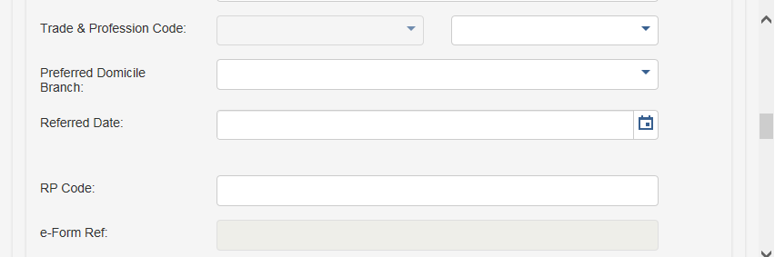

#Mandatory if department is

BB or WBG

**#Mandatory Field**

**#Mandatory Field**

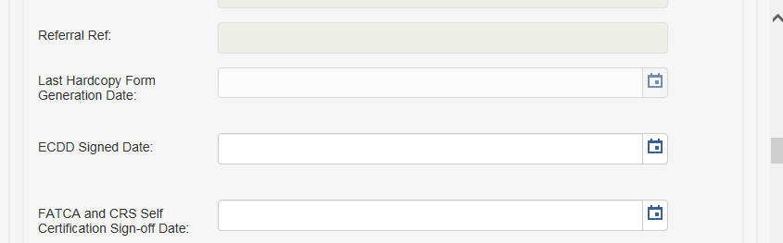

#Mandatory when risk score >=3

**#Mandatory Field**

#Mandatory for

Sole-Proprietor

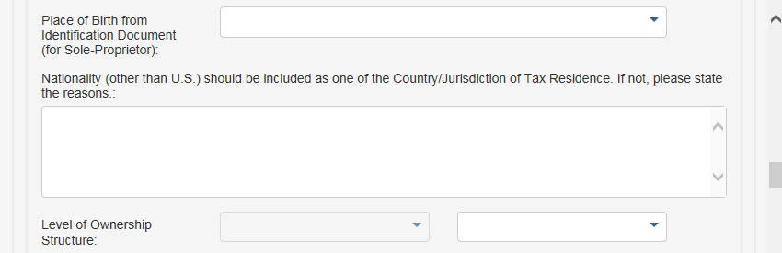

**#Mandatory Field**

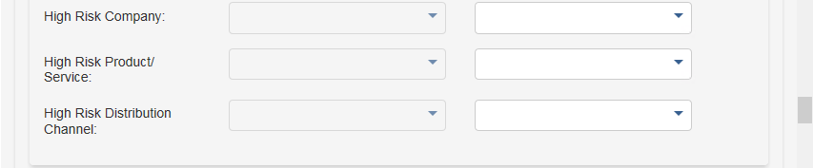

**#Mandatory Field**

**#Mandatory Field**

**#Mandatory Field**

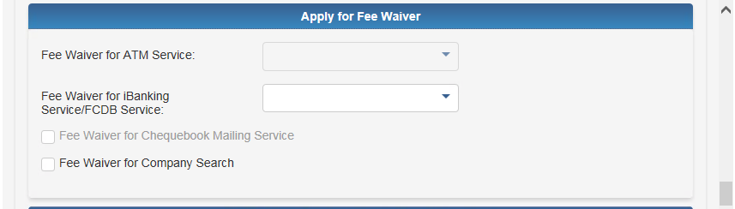

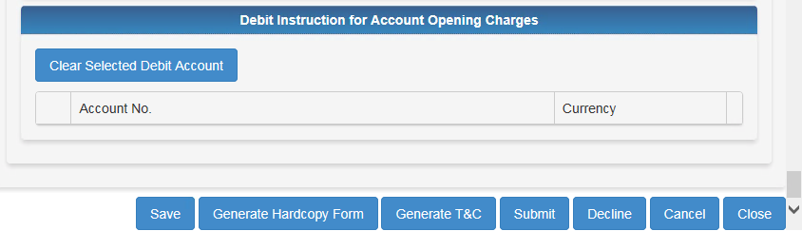

**5.7.2 Compliance Check**

1. Compliance check result will be displayed under Bank Use Only tab.
2. User can trigger a compliance check by clicking the Compliance Check button, including company, related parties and authorized signatory.
3. Risk Score checking result will be displayed and the score will be shown on the score box below
4. Negative list checking and AML (name scanning) will be shown using a table format for company, related party and authorized signatory.

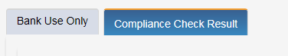

**#Click “Compliance Check '' button to retrieve risk scoring result**

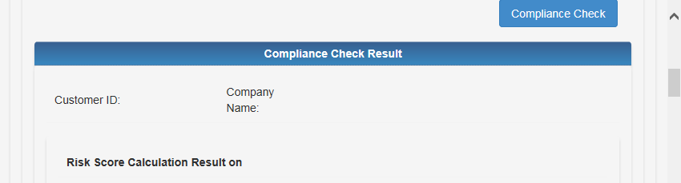

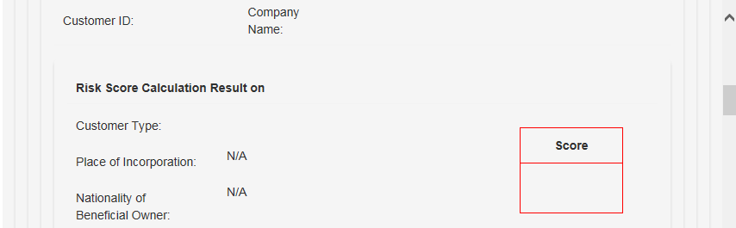

**#Score Box**

**#Mandatory**

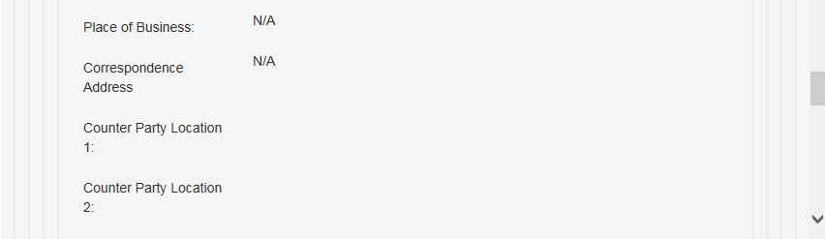

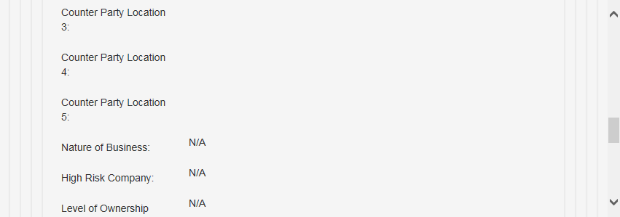

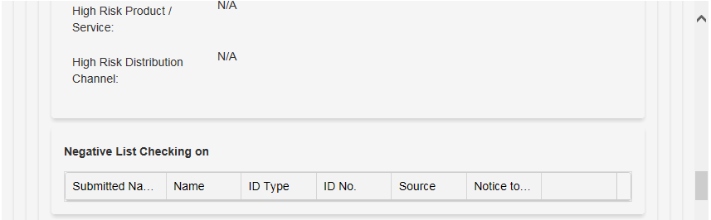

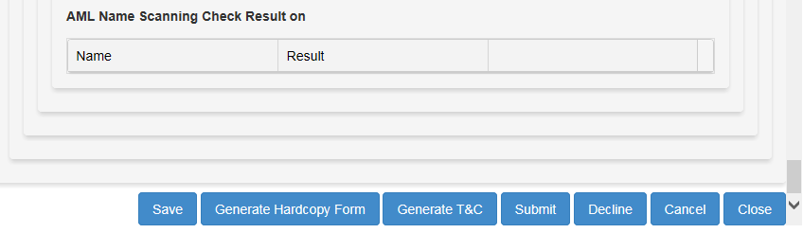

After clicking the Compliance Check button, the sample of the Compliance Check Result will be displayed as below.

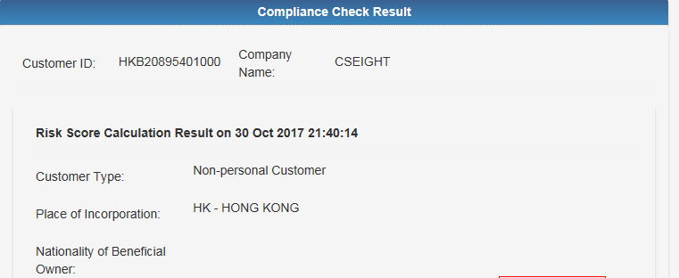

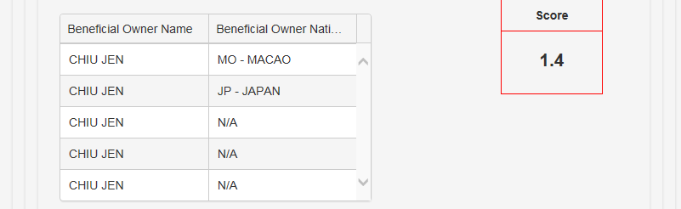

**#Risk Score**

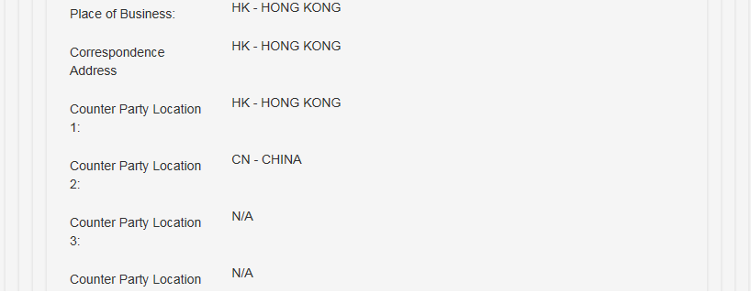

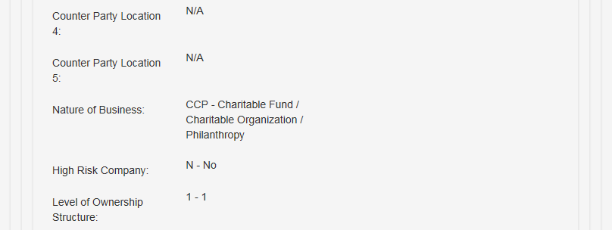

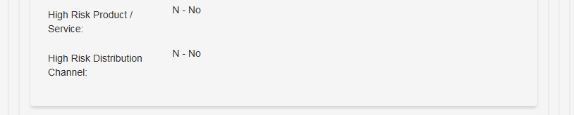

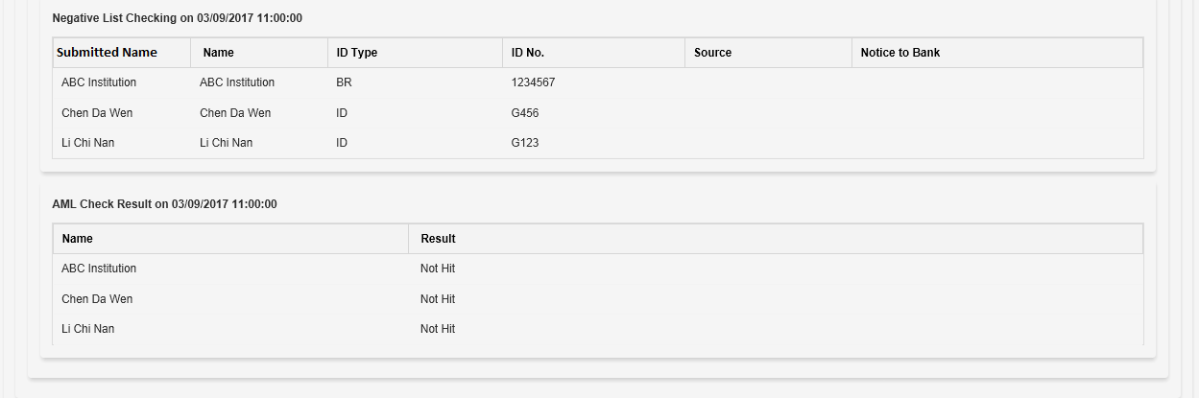

**Remarks:**

1. If there is any HIT on Negative List Checking & AML name scanning, users need to perform further study/analysis of the “hit” entity separately (as per BAU).
2. In order to record the Compliance Check Result, user needs to copy the content and paste it in a word file. Then, print the word file out and submit it to BLO with the account opening documents.

## Workflow History

1. This tab will list out the process history of the application. The process log will be sorted by Action Date in descending order.
2. User can export process log records to an Excel file.
3. User can fill in comment in the User’s message box, the content will be shown in the remarks field of the process log after user submits the BPM task.
4. The section of Follow up reason will be appeared for BLO user to return the form to RM maker, details please refer to Functional Requirements Specifications for Corporate Account & Maintenance System (CAMS).
5. “Conduct Compliance Check” action will also be added to the process log after user presses the compliance check button.

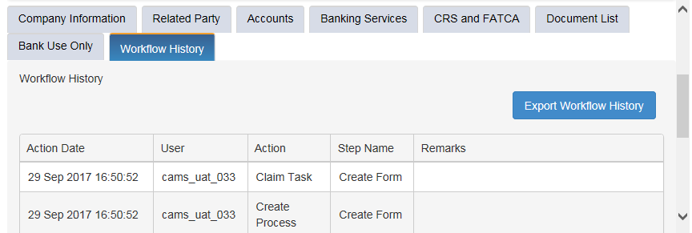

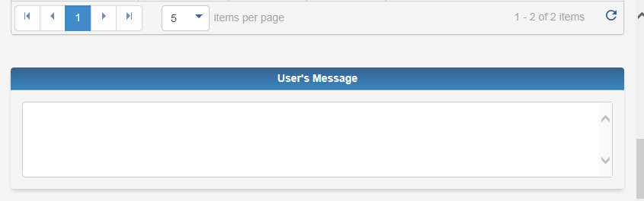

# To Go Before Click “SUBMIT”

* 1. Click **“Generate Hardcopy Form”**, to **print out** the Account Application Form for Business Customers to sign, after 8 TABs completely filled in.



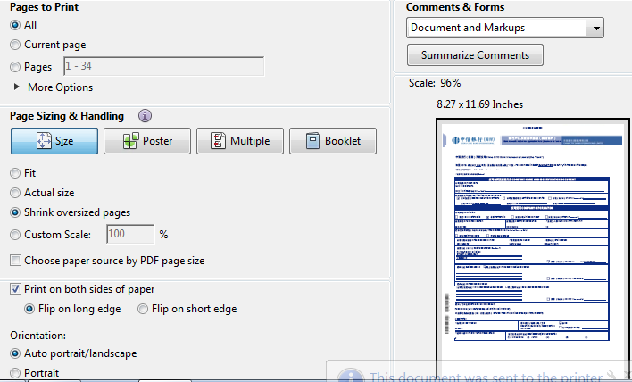

****2. To Click “**Save**”, before submitting out the completed forms****

3. After submitting, error Page will be displayed, if any missing fields. The users need to ensure the form completeness and correctness.

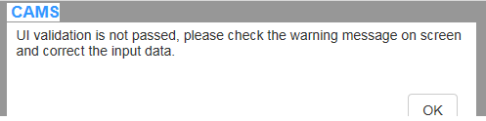

4. Successfully submit, there is no task stored in the Maker‘s task work.

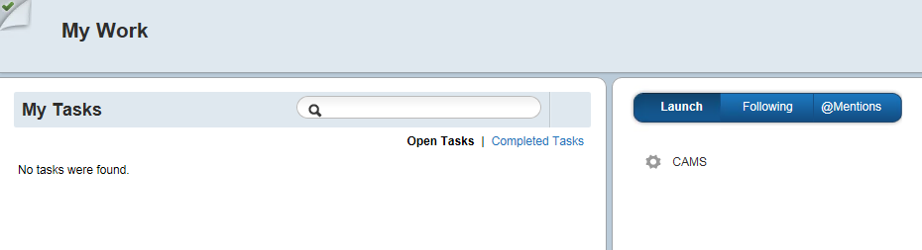

No Task Found

<<End of Document>>